Registration Instructions

STEP 1: Determine what classes you need to register for by viewing your advising worksheet.
Log in to MyTech, on the home page scroll down to the academics box and click View my advising worksheet.
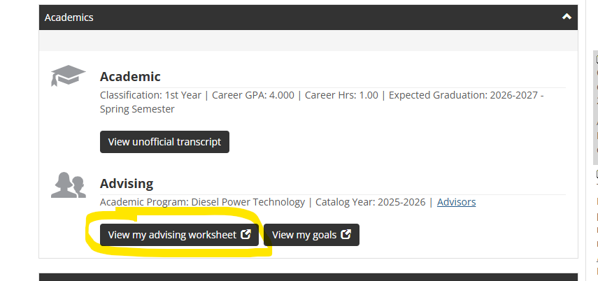

Everything you are currently enrolled in will show as a gold circle. Red X’s are courses you need to take. Green checks are courses you have completed. Register for everything you need for the upcoming semester and anything that you need to retake or catch up on from a prior semester. In the below example, this student would register for everything under the second semester heading, as well as TRAN100 from the first semester. Consult with your advisor if you are unsure of your plan of study.
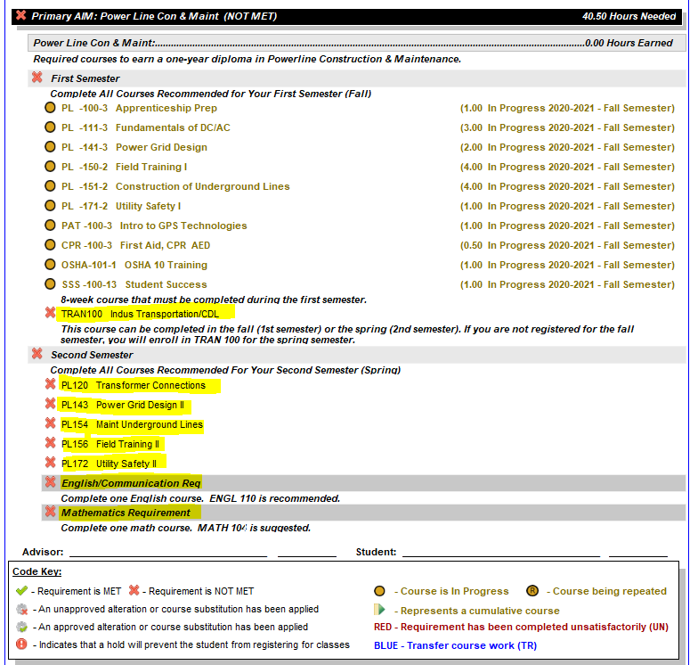
All transfer credit should be showing as a green check on your advising worksheet. If something doesn’t look right or you think something is missing, please stop by the registrar’s office or email jill.greenway@mitchelltech.edu and I will look into it.

To transfer credit, we must have an official transcript. We cannot transfer courses from a high school transcript. You must have the college you took the dual credit through send us an official transcript. That means it must come from the previous college, directly to us. You can’t have it mailed or emailed to yourself first and then give it to us.

STEP 2: Registration
Click on Academics, then Registration

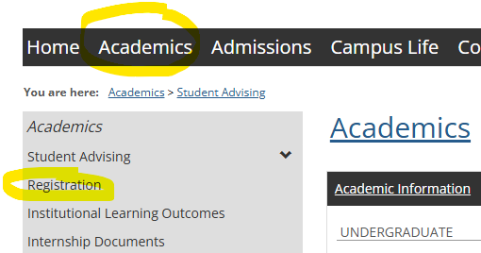

That will bring up this screen:

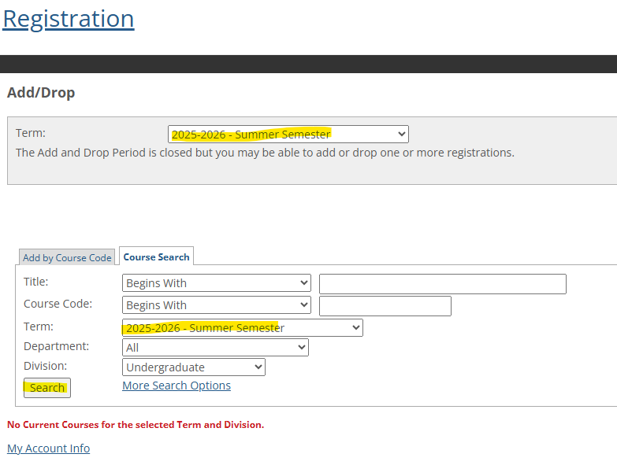

In the term drop down box, be sure to select the term you will be registering for: 2025-2026 Summer Semester and/or 2026-27 Fall Semester.

For best results, make sure both boxes have the correct semester and you are clicked on the course search tab and click search. This will bring up all courses for the semester.
Use the alphabet guide at the bottom of the screen to go to the page with the course you need. If the class is available for you, there will be a box that you can check to add to registration. Select all the courses you need to register for, then click Add Courses at the bottom of the screen.
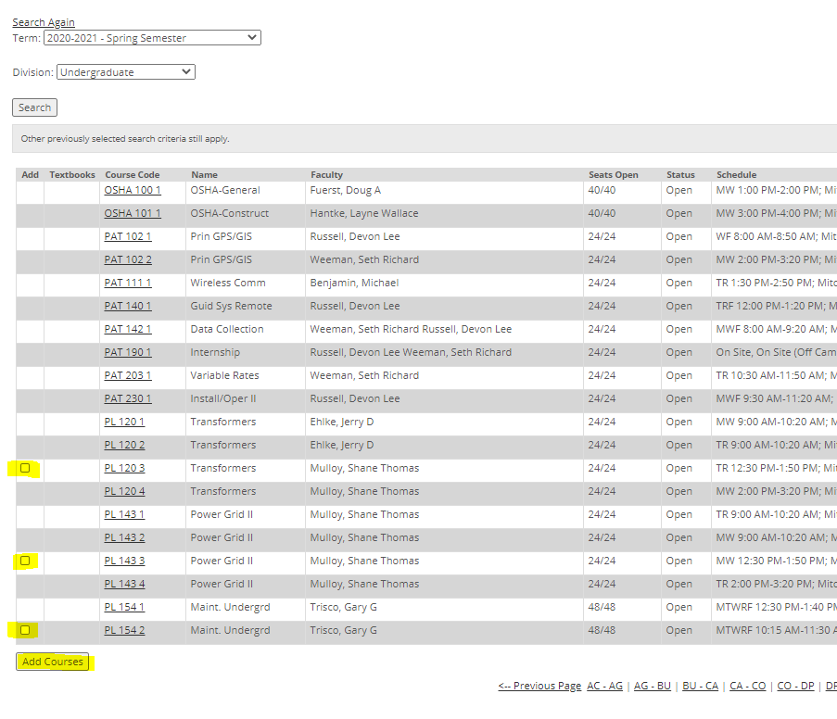

A message will come up to tell you if it was registered successfully or if there was an error.
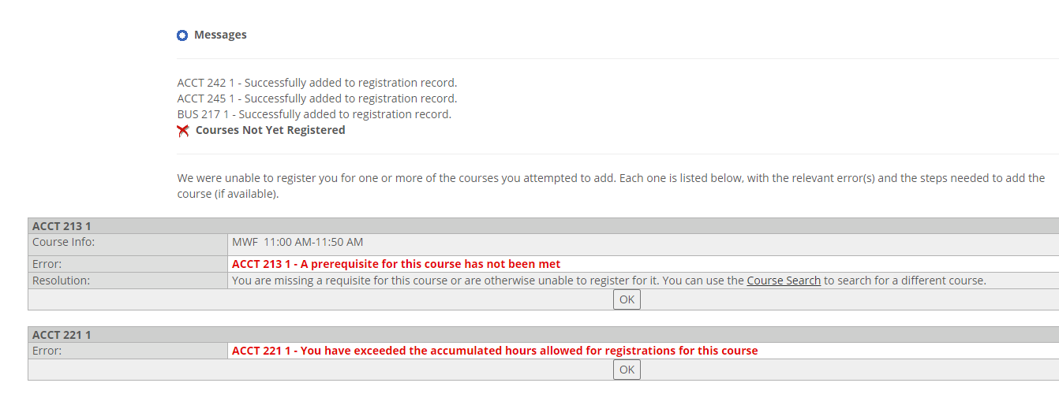

Look for any messages that say that you were unsuccessful. You may not have a required prerequisite, the course may be full, you may have a hold on your account. If you receive a message that is unexpected, let me know so I can check into it. If a course is full, let me know. It might be an error, or we may need to get you into another section. When in doubt, ask.
If you need a class that wasn’t available, let me know so I can add it for you.

General Education Classes-Here is a guide to general education classes if the course number isn’t specified on your advising worksheet. Please note: not every class will be offered every semester and requirements may vary depending on specific program requirements.
Behavioral Science Requirement: CMST 201 Interpersonal Communications or PSYC 101 General Psychology
Social Science Requirement: SOC 150 Social Problems
Math Requirement: MATH 103 Mathematical Reasoning or MATH 162 or MATH 112 for certain programs
Written Communications Requirement: ENGL 110 Workplace Communications OR ENGL 101
English Composition ** Which class you need will depend on the program, check your
advising worksheet
Communications: ENGL 110, ENGL 101, or CMST 101 Fundamentals of Speech
ENGL 098 is only for certain students depending on your placement test scores. Do not register for this course unless it is listed on your advising worksheet.
Math 091 is only for certain students depending on your placement test scores. Do not register for this course unless it is listed on your advising worksheet.

STEP 3: After registering, check your advising worksheet again to make sure you see gold circles in front of the classes you have registered for. If you see any red x’s on that term, you need to try again to register for the class. Checking your advising worksheet again is a good way to double check that you got registered for everything you intended to. Don’t skip this step.

The schedule is subject to change. Periodically check your schedule on MyTech for any changes in times or classrooms.

If you have any questions or run into any issues at all, please ask.

You are responsible for making sure you meet the requirements for graduation.

