Life's most persistent and urgent question is,
'What are you doing for others?'
Martin Luther King, Jr,

In June 2015 I had the opportunity to represent Mitchell Tech at the ACT College and Career Readiness Awards in Washington, D.C. In addition to accepting ACT’s Career Preparedness Award for Mitchell Tech, I was able to spend a couple days sight-seeing with my wife, Sonya.

It was my first time in Washington, D.C., and we packed in as many of the sights as we could see during our time in the city. One of the landmarks we were able to visit was the Martin Luther King, Jr. Memorial. I took the following picture during our visit at the memorial.

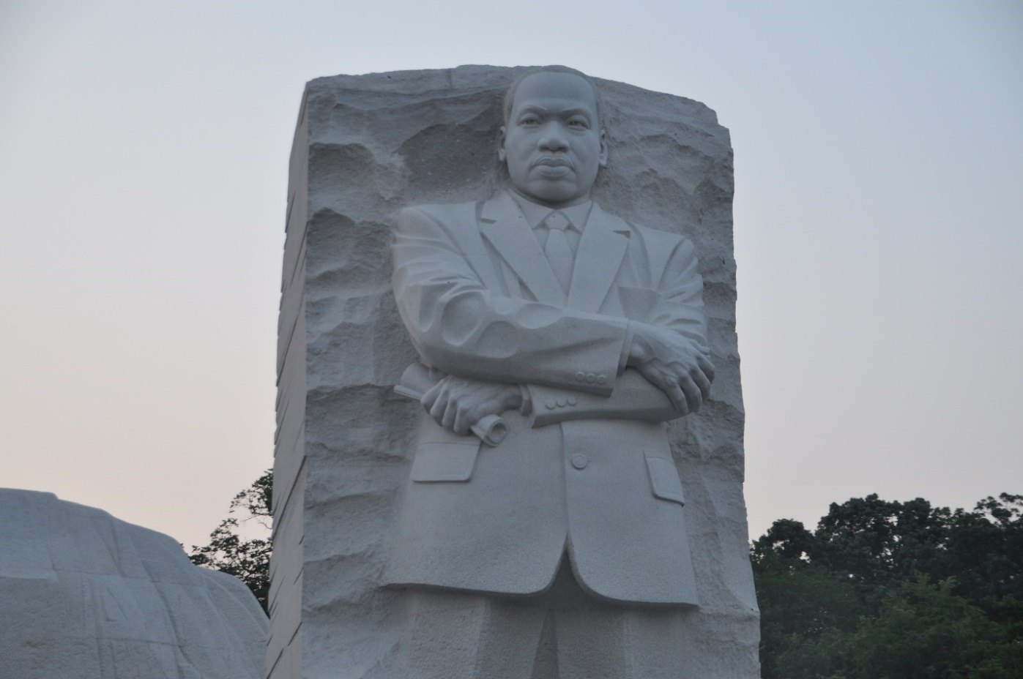

As with many of the memorials in D.C., the Martin Luther King, Jr. Memorial was very moving. The memorial was even more extraordinary as I learned more about the symbolism associated with it. However, I spent most of my time at the memorial reading and reflecting on the quotes of Martin Luther King, Jr. that are carved in the stone around the memorial. In all, there are fifteen quotes featured at the memorial. The following is a list of my five favorite quotes that are carved into the stone:
- "The ultimate measure of a man is not where he stands in moments of convenience and comfort, but where he stands at times of challenge and controversy."
- "Injustice anywhere is a threat to justice everywhere.
- "True peace is not merely the absence of tension; it is the presence of justice."
- "Out of the mountain of despair, a stone of hope."
- "Darkness cannot drive out darkness, only light can do that. Hate cannot drive out hate, only love can do that."

However, my favorite quote from Martin Luther King, Jr. is not carved into the stone of his memorial. My favorite quote, “Life's most persistent and urgent question is, 'What are you doing for others?'” makes me pause and evaluate how I am using my time and energy to help others.

So, I’ll ask you, what are you doing for others? Are you giving a pen and paper to someone who doesn’t have anything to take notes with? Are you wearing a mask to keep others safer from COVID-19? Are you a listening ear for someone who is struggling?

As we honor Martin Luther King, Jr., my challenge to you – today and every day – is to find a way to “do for others.” It could be holding a door open for people as they enter a building or a room or scrapping off the windshield of the car next to you in the parking lot or helping a friend in your program that didn’t understand the last assignment. The person you help will appreciate your kindness and thoughtfulness and you will be on your way to finding inner peace.

Take care.

